**Top Line Analysis**

Chi-Lun, Mai

**Item abbr:** 1131-24S(31), 1133-24S(33), 1140E-24S(40), 1142E-24S(42), 1144E-24S(44)

**Abstract:**

* Item 33, 40, 42, and 44 are winter goods and they should be “complements” for each other. Nov and Dec are busy season for these items. In my opinion, there are probably some promotions in Mar and Apr.
* Item 31 is probably a product appeared in commercial activities which are held twice a month in Jul, Aug and Sep.
* These data are from the physical store that Sat is usually not available. This store usually holds commercial activities at Mon, Tue and Wed.
* I built the model to predict the sales of each item, please check out section Sales Model.
* Item 33, 40, 42, and 44 are probably provided by the same supplier.

**Content:**

1. Product Sales

We can find that each item is seasonal goods in Figure 1. Busy season for item 31 is in 3-4Q, and the busy season for the others should be in 2Q and 4Q. The peaks in Figure 1 are probably some days that the store hold commercial activities, and we can find the peak of item 31, 40, 42 and 44 overlaps, because they are same time to promote.

Figure 1 Item Trend Chart

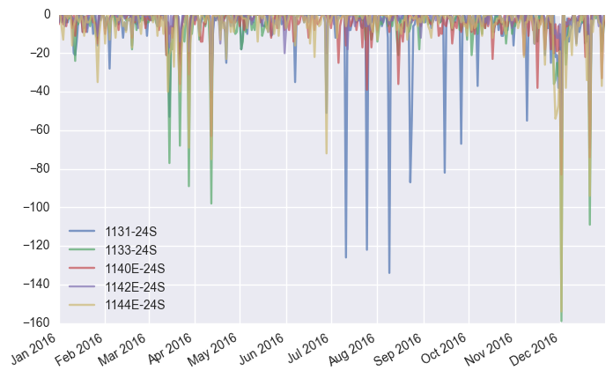

Each items can be sold 4-6 (except for item 24) per day according to Table 1, but the standard error is so large that the average number is not very useful. We should focus on these product seasonal properties to enhance the sales.

Table 1 Sale Statisitics

|  | **1131-24S** | **1133-24S** | **1140E-24S** | **1142E-24S** | **1144E-24S** |
| --- | --- | --- | --- | --- | --- |
| **mean** | -6.2869 | -5.0956 | -4.4098 | -2.4180 | -5.7322 |
| **std** | 15.8083 | 14.0330 | 8.9682 | 5.5747 | 13.5507 |
| **min** | -134.0000 | -159.0000 | -83.0000 | -64.0000 | -154.0000 |
| **25%** | -5.0000 | -5.0000 | -5.0000 | -3.0000 | -6.0000 |
| **50%** | -2.0000 | 0.0000 | -2.0000 | 0.0000 | -1.0000 |
| **75%** | 0.0000 | 0.0000 | 0.0000 | 0.0000 | 0.0000 |
| **max** | 0.0000 | 0.0000 | 0.0000 | 0.0000 | 0.0000 |

1. Inventory

Apparently, inventory level of item 31 is higher than the others, the reasons is that sales of item 31 is not very high so we can think this item is maybe not a normal product, it’s probably a product appeared in commercial activities so we don’t care about the inventory turnover. If this item are sold out we just purchase other item to replace it, and if this item inventory is too high we just hold the commercial activities to digest it. The inventory of item 31 is very high at the beginning of the year. In my opinion, it’s maybe a outlet item of last year or a commercial activity product just purchased.

Figure 2 Inventory Trend Chart

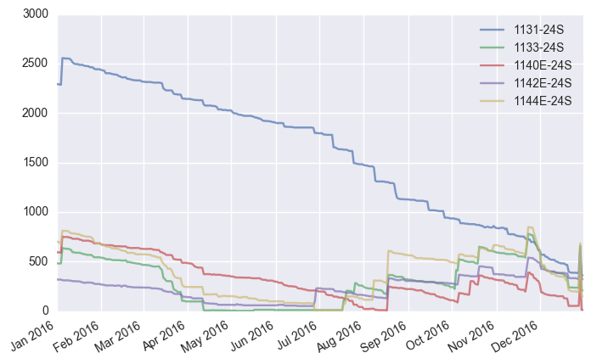

1. Relationship for Item

There are high relations of sales within item 33, 40, 42, and 44 in Figure 3, so I predict that they are complements for each other. Although item 31 has positive relation with the others but not very high, so item 31 is a different type of product compared to the others.

Figure 3 Item Correlation Matrix

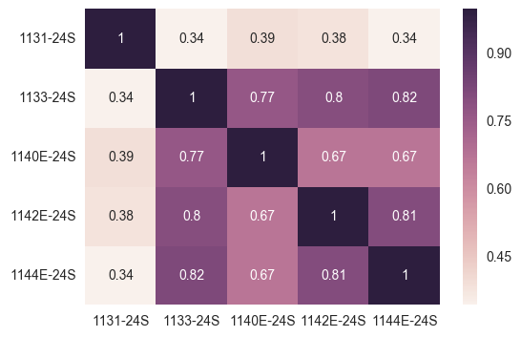

1. Operations Analysis

We can find that sales are almost 0 for all items in the Sat (0 is Mon, 1 is Tue, … 6 is Sun) according to Figure 4. I can predict these data are from the physical store that Sat is usually not available. In the Figure 5, we can compare each number to mean number of each item sales from Table 1, then we can define that month which average sales per month greater than average sales (per year) is belong to busy season (see red rectangle in Figure 5). If we don’t take account of item 31 (because it’s different type of item from the others), in general, item 33, 40, 42, 44 have same busy season in Mar, Apr, Nov and Dec. These items probably are winter goods and there are some promotions in Mar and Apr.

Figure 4 Item Sales by Day of Week

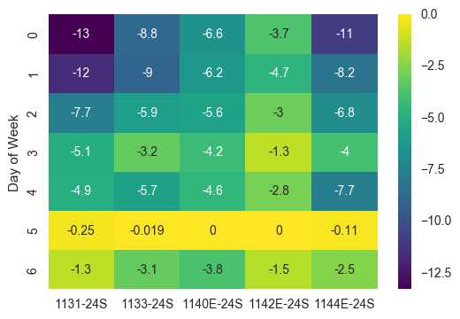

Figure 5 Item Sales by Month

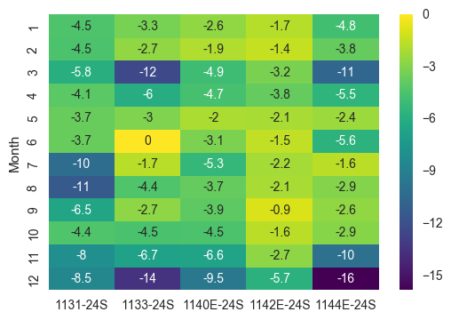

1. Sales Model

I try to build a sales model to explain the effect of busy season and each day of week (this part is not for item31 because it’s different type of item from the others). First, I have to drop the outliers that would be produced by specific commercial activities. Next, I get dummy variable from busy season and week of day, so I build the model as follows.

$$sales=b_{0}+b_{1}*busySeason+\sum_{i=2}^{7}{b_{i}*Day of Week\left(i-2\right)}$$

$$Day of Week\left(0\right)=Mon, Day of Week\left(1\right)=Tue, and so on.$$

In my coding practical, I used dummy variable Busy Season, Mon, Tue, Wed, Thu, Sat, and Sun, there’s no Fri just because Fri is a first column and we delete it to avoid collinearity problem. Now we can check out the result from Table 2.

Table 2 Coefficient of Items

|  | **1133-24S** | **1140E-24S** | **1142E-24S** | **1144E-24S** |
| --- | --- | --- | --- | --- |
| **Busy Season** | -2.3557 | -0.6552 | -1.1762 | -3.5991 |
| **Mon** | -4.6210 | -2.2668 | -2.1765 | -4.2427 |
| **Tue** | -1.8897 | -1.4268 | -1.7465 | 0.1917 |
| **Wed** | -1.1364 | -0.4868 | -0.6116 | 0.5212 |
| **Thu** | -0.4162 | -0.0468 | 0.2919 | 0.9346 |
| **Sat** | 2.7418 | 3.0660 | 1.5919 | 4.7787 |
| **Sun** | -0.4491 | -0.7626 | 0.0543 | 2.3154 |
| **intercept** | -1.9606 | -2.8435 | -1.1924 | -3.6695 |

Now we can predict the sales from this model, there are 2 parts of result according to whether that month is busy season or not, check out Figure 6 and Figure 7.

Figure 6 Sales Prediction without Busy Season

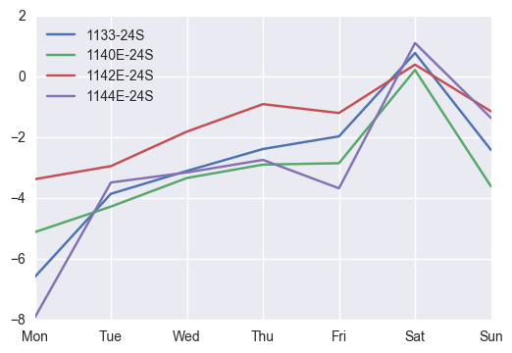

Figure 7 Sales Prediction with Busy Season

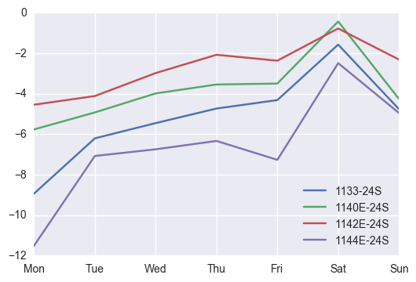

1. Supplier

By GAAP or IFRS, the difference between inventory is caused by many reasons such as selling out the product, purchasing and returning items. I viewed this difference as the item sales, if the value is not equal to sales, I treated it as purchasing. So I can plot the purchasing run chart out as Figure 8. If value is greater than 0 which means the store purchase the item, or there is a situation that the store sales the item on credit. I’ve calculated the correlation matrix within each item as Figure 9. I think item 33, 40, 42, 44 are provided by the same supplier owing to their high correlation.

Figure 8 Purchasing Run Chart

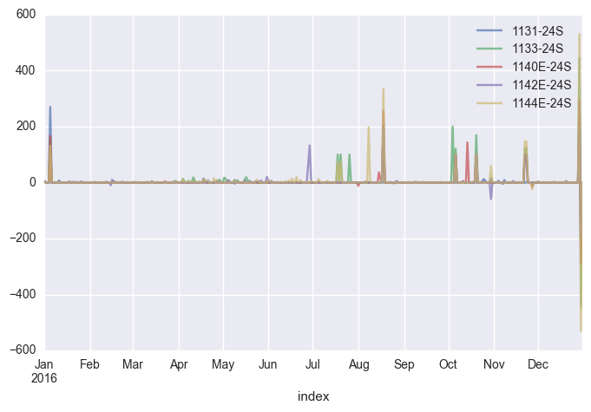

Figure 9 Purchasing Correlation Matrix

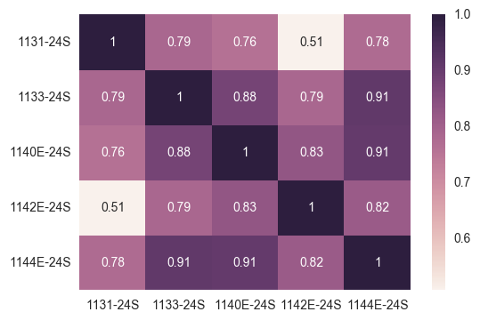

1. Appendix

Figure 10 Mean Sales of 1131-24S by Month

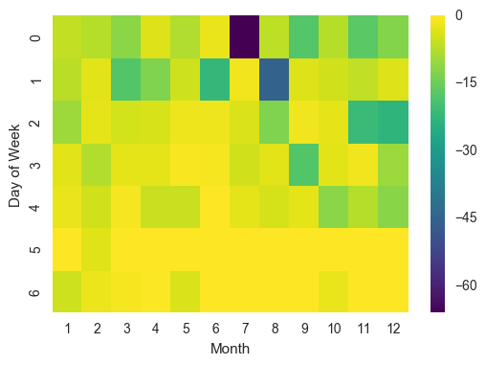

Figure 11 Mean Sales of 1133-24S by Month

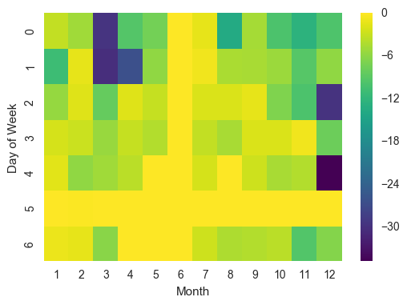

Figure 12 Mean Sales of 1140E-24S by Month

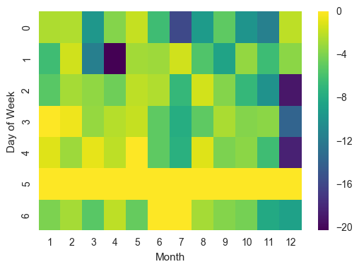

Figure 13 Mean Sales of 1142E-24S by Month

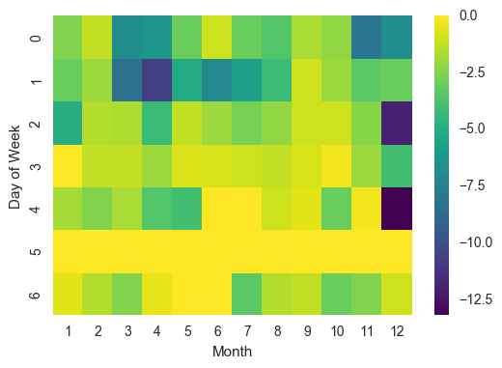

Figure 14 Mean Sales of 1144E-24S by Month

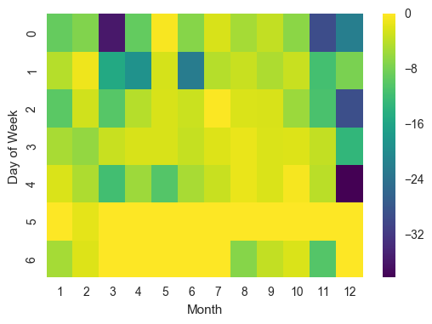

Table 3 Sales Prediction without Busy Season

|  | **1133-24S** | **1140E-24S** | **1142E-24S** | **1144E-24S** |
| --- | --- | --- | --- | --- |
| **Mon** | -6.581662 | -5.110340 | -3.368855 | -7.912246 |
| **Tue** | -3.850301 | -4.270340 | -2.938862 | -3.477838 |
| **Wed** | -3.097125 | -3.330340 | -1.804004 | -3.148282 |
| **Thu** | -2.376879 | -2.890340 | -0.900539 | -2.734920 |
| **Fri** | -1.960642 | -2.843496 | -1.192389 | -3.669518 |
| **Sat** | 0.781175 | 0.222516 | 0.399472 | 1.109135 |
| **Sun** | -2.409790 | -3.606096 | -1.138086 | -1.354117 |

Table 4 Sales Prediction with Busy Season

|  | **1133-24S** | **1140E-24S** | **1142E-24S** | **1144E-24S** |
| --- | --- | --- | --- | --- |
| **Mon** | -8.937345 | -5.765527 | -4.545077 | -11.511367 |
| **Tue** | -6.205984 | -4.925527 | -4.115084 | -7.076959 |
| **Wed** | -5.452808 | -3.985527 | -2.980226 | -6.747402 |
| **Thu** | -4.732562 | -3.545527 | -2.076760 | -6.334040 |
| **Fri** | -4.316325 | -3.498684 | -2.368611 | -7.268639 |
| **Sat** | -1.574507 | -0.432671 | -0.776750 | -2.489985 |
| **Sun** | -4.765473 | -4.261284 | -2.314307 | -4.953237 |

Table 5 Best Sales (>50 per day)

| **Date** | **1131-24S** | **1133-24S** | **1140E-24S** | **1142E-24S** | **1144E-24S** |
| --- | --- | --- | --- | --- | --- |
| **2016-03-15** | -53 | -77 |  |  |  |
| **2016-03-22** |  | -68 |  |  |  |
| **2016-03-28** |  | -89 |  |  | -69 |
| **2016-04-12** |  | -98 | -63 |  | -75 |
| **2016-06-28** | -51 |  |  |  | -72 |
| **2016-07-11** | -126 |  |  |  |  |
| **2016-07-25** | -122 |  |  |  |  |
| **2016-08-09** | -134 |  |  |  |  |
| **2016-08-23** | -87 |  |  |  |  |
| **2016-08-24** | -55 |  |  |  |  |
| **2016-09-15** | -82 |  |  |  |  |
| **2016-09-26** | -67 |  |  |  |  |
| **2016-11-09** | -55 |  |  |  |  |
| **2016-11-28** |  |  |  |  | -54 |
| **2016-11-29** |  |  |  |  | -51 |
| **2016-12-02** |  | -159 | -83 | -64 | -154 |
| **2016-12-21** | -69 | -109 | -74 |  | -94 |